Lockbox Inventory Report

- From Clarity SSO. Click on the Sentrilock Icon - https://ranww.clareity.net/layouts
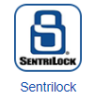

- Click on Reports from the top bar.
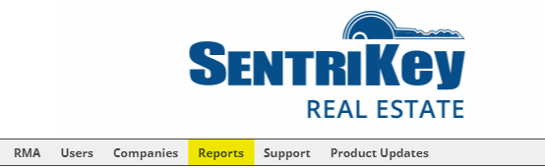

- Click on Download as CSV next to Lockboxes.
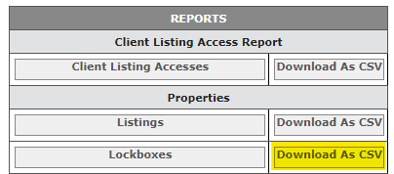

- You now have a sortable, printable excel spreadsheet with your lockbox inventory.
